Max Shi  
Professor de Rosa  
E 234  
September 23, 2020  
I pledge my honor that I have abided by the Stevens Honor System.

Homework 2

1.

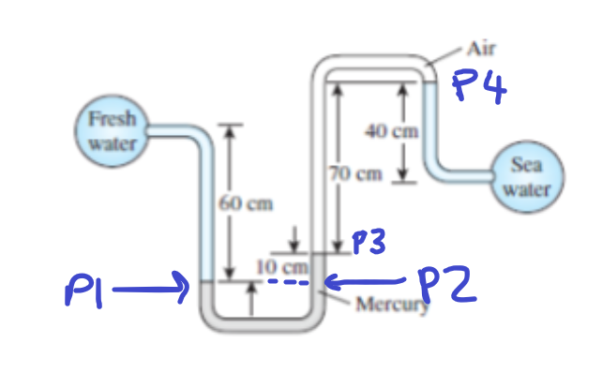

$$P_{1}=P_{2}=P_{fw}+0.60*9.81*1000=P_{fw}+5886 \\ P_{3}=P_{2}-0.10*9.81*13600=P_{2}-13341.6=P_{4} \\ P_{4}=P_{sw}-0.40*9.81*1035=P_{sw}-4061.34 \\ P_{fw}+5886-13341.6=P_{sw}-4061.34 \\ P_{fw}=P_{sw}+3394.26 Pa$$

The pressure difference is 3394.26 Pa. The pressure in the air the tube can be neglected because its density, approximately 1.225 kg/m3, is orders of magnitude lower than even the least dense fluid in this system, water, at 1000 kg/m3. Therefore, as pressure is defined as density * gravity * height, the pressure that air exerts is negligible.

2. It is not possible to have water vapor at -8 degrees Celsius because of water’s freezing point, which, although could change somewhat due to pressure, stays around 0 degrees Celsius. Therefore, water vapor at -8 degrees C would just be a solid.

3. To cook the stew in the least amount of time, we would want to maximize the temperature of the stew. Therefore, we should increase the saturated temperature, which can be done by increasing the pressure. The heavier lid will allow the most pressure buildup through evaporation, so that is the lid that should be used to cook the stew in the least amount of time.

4. The main difference in these diagrams is the slope of the line as v increases, and which variable stays constant along the curve. As v increases in the T-v diagram, the temperature must go up as the pressure stays constant. As v increases in the P-v diagram, the pressure must go down while temperature stays constant. However, the states are still the same on different elements of the graph (i.e. from left to right, the states go from compressed liquid to superheated vapor)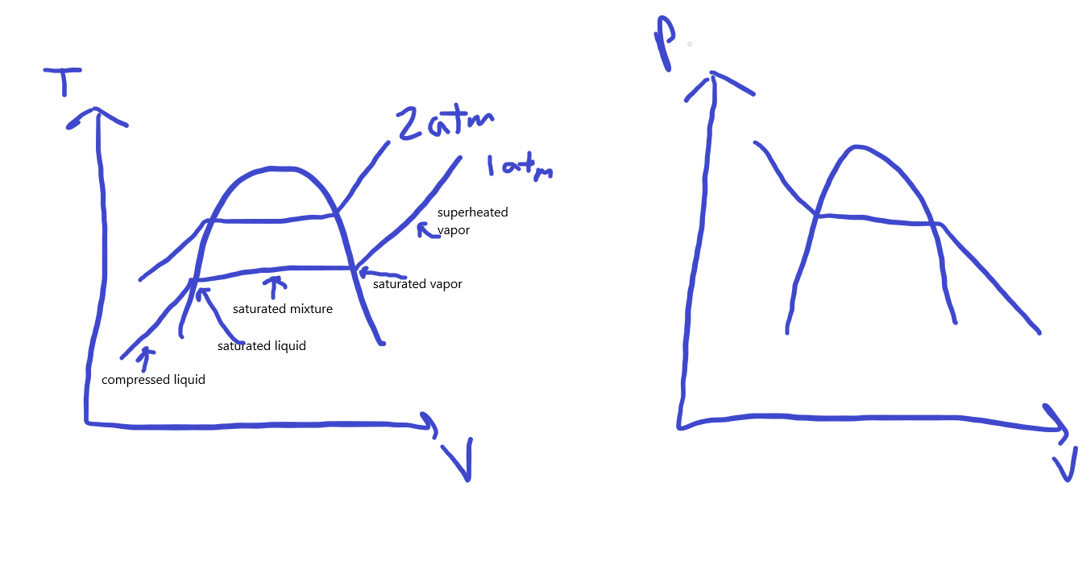

5.

|  |  |  |  |  |
| --- | --- | --- | --- | --- |
| T (deg. Celsius) | P (kPa) | h (kJ/kg) | x (quality) | Phase description |
| 120.21 | 200 | 2045.83 | 0.7 | Saturated mixture |
| 140 | 361.53 | 1800 | 0.565 | Saturated mixture |
| 177.66 | 950 | 752.74 | 0.0 | Saturated liquid |
| 80 | 500 | 335.02 | N/A | Compressed liquid |
| 350 | 800 | 3162.2 | N/A | Superheated vapor |

6.

|  |  |  |  |  |
| --- | --- | --- | --- | --- |
| T (deg. Fahrenheit) | P (psia) | h (Btu/lbm) | x (quality) | Phase description |
| 65.89 | 80 | 78 | 0.566 | Saturated mixture |
| 15 | 29.759 | 69.92 | 0.6 | Saturated mixture |
| 10 | 70 | 15.308 | N/A | Compressed liquid |
| 160 | 180 | 129.46 | N/A | Superheated vapor |
| 110 | 161.16 | 117.25 | 1.0 | Saturated vapor |

7.

$$V=\frac{v}{m}=\frac{9}{900}=\frac{0.01{ m}^{3}}{kg}$$ This specific volume is between the specific volume of a saturated liquid and a saturated vapor of R134a at 10 degrees Celsius, which means we have a mixture.

8. If pressure is constant, then the final pressure is the same as the initial pressure.

$$V=\frac{v}{m}=\frac{2.4264 ft^{3}}{1 lbm}=2.4264\frac{ft^{3}}{lbm}$$ Looking this up in the table, this specific volume is between the specific volume of a saturated liquid and vapor of water at this temperature, so we have a saturated mixture. This implies the pressure is 1542.5 psia from the table. When cooling this to 200°F, the associated saturated pressure is 11.538 psia. This means that the substance is now a compressed liquid, which at 200°F, means the specific volume is now 0.01663 ft3/lbm, which means the volume is:

$$v=Vm=0.01663*1=0.01663 ft^{3}$$

